# Computer Vision Hw3 Report

* Discription
  + Histogram Equalization
* Algorithm
  + 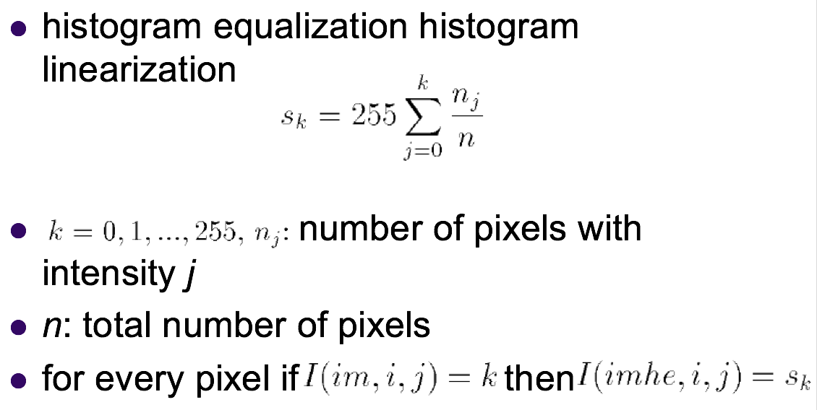
* Parameters (if any)
  + no
* Principal Code Fragment

Histogram equalization

(file – /src/cv1.util.cv /ImgUtil.java)

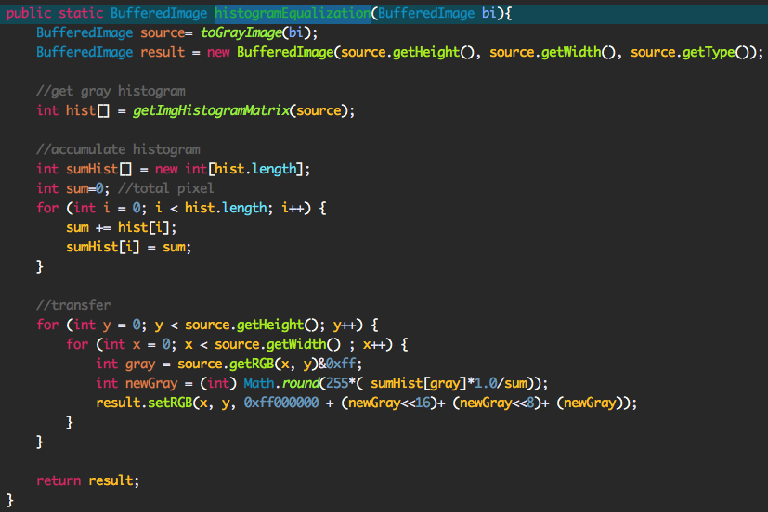

* Resulting Images

Histogram equalization

